About the App

What’s in the app:

* This app would mainly be having two functions provided to you by two separate windows (i.e. activities).
* The first window would allow u to establish Bluetooth connection from the list of your paired devices, display the name and mac address of the connected device.
* While the second window (or activity) would provide the full screen control interface to control you robot/embedded project from your smartphone.

(Note: This window would only be available only when you have established a successful connection between your phone and the Bluetooth module)

* The app buttons. Which are as follows:

1. “Connect”

This would give you a pop-up window with the list of paired Bluetooth devices. And once you touch any one paired device it would try to establish connection with that device.

1. “Disconnect”

This would disconnect your smartphone from the already connected Bluetooth device and take you to your home activity.

1. “Control”

When you are connected to a device it would give full screen Touch Interface for sending the coordinates where your finger touches the screen.

*further functionality like accelerometer, GPS, PWM, Serial terminal etc. would be added in newer versions.

Using the app:

*First of all you need to make sure you have paired the Bluetooth device you wish to get connected to, as the app can connect only to the list of paired devices.

* As the app is started it looks if you have or haven’t enabled Bluetooth on your smartphone. If it’s found disabled you are presented with a request dialogue to enable it, if you reject that request the app automatically exits itself out.
* When the Bluetooth is enabled the first window will show you your connection status and “Connect” button on screen.
* For making connection to your Bluetooth device (i.e. Bluetooth module) you need to click on button “Connect”. Once you do this, you will be given pop-out dialog view of the list of paired devices. Select the name of your Bluetooth device to establish connection.
* If a connection is established successfully between your smartphone and the module. The mac address and the name of the device you are connected would be displayed on screen.
* You will notice the “Control” button below the “Connect” button would now be enabled.
* Now you can open the Control Interface by clicking the “Control” button.

And you are good to go…!!

Understanding how the app sends data:

The app uses separate Thread with a loop to send data continuously after every 100ms (this would be user configurable in further versions of the app) in form of a byte*.

*(Which could be type casted to int(Interger) as well char(Character) as per convenience)

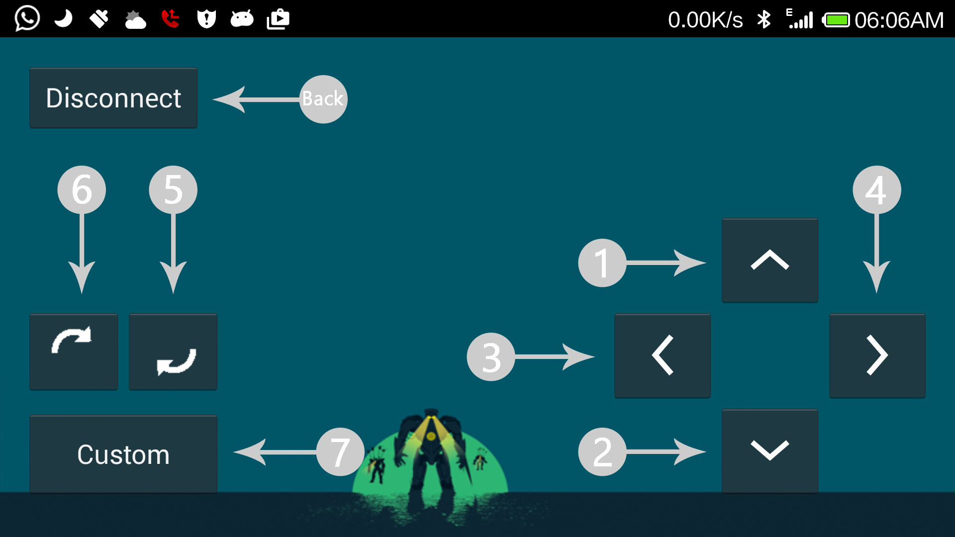

Which key/button would send will send which byte can be seen in the table:

|  |  |  |  |  |  |  |  |
| --- | --- | --- | --- | --- | --- | --- | --- |
| Key | *1* | *2* | *3* | *4* | *5* | *6* | *7* |
| Data(char) | “1” | “2” | “3” | “4” | “5” | “6” | “7” |
| Data(int ) | 48 | 49 | 50 | 51 | 52 | 53 | 54 |
| Data(byte) | 48 | 49 | 50 | 51 | 52 | 53 | 54 |

For example:

#### If the key 1 is pressed on the screen. The data send would be single char i.e.“1” which could be type casted and used to establish control over Arduino as follows:

**Int read;**

**read=Serial.Read();**

**if(read==48){**

**//Write your code for what to do**

**}**